Problem Statement
Economic research routinely combines heterogeneous objects: long time series for a single country, cross-indicator relationship matrices, nested country metadata, and rectangular panel data with categorical labels (region, income group). The task is to practise the four core R structures (vector, matrix, list, data frame + factor) on a realistic multi-country panel so that the same scientific workflow can be reproduced cleanly and extended.

Solution Strategy
1. Load panel → inspect dimensions. 2. Extract atomic vectors (country growth series, yearly averages). 3. Build correlation & covariance matrices of the four numeric indicators. 4. Construct named lists / nested lists that bundle country identity with its series. 5. Promote region and income_group to factors (ordered for income). 6. Summarise by region with both dplyr and pure base-R. 7. Monte-Carlo: vary process volatility and record sampling variability of the estimated mean growth.

Solution
Key findings: Oceania (4.36 %) and Asia (3.36 %) show the highest average GDP growth; North America records the highest average inflation (5.22 %). Overall correlation between growth and inflation is modestly negative (–0.18). Ordered factors on income group and region factors enable clean group-wise analysis. Sampling SD of a 11-year mean scales linearly with the volatility of the underlying process.
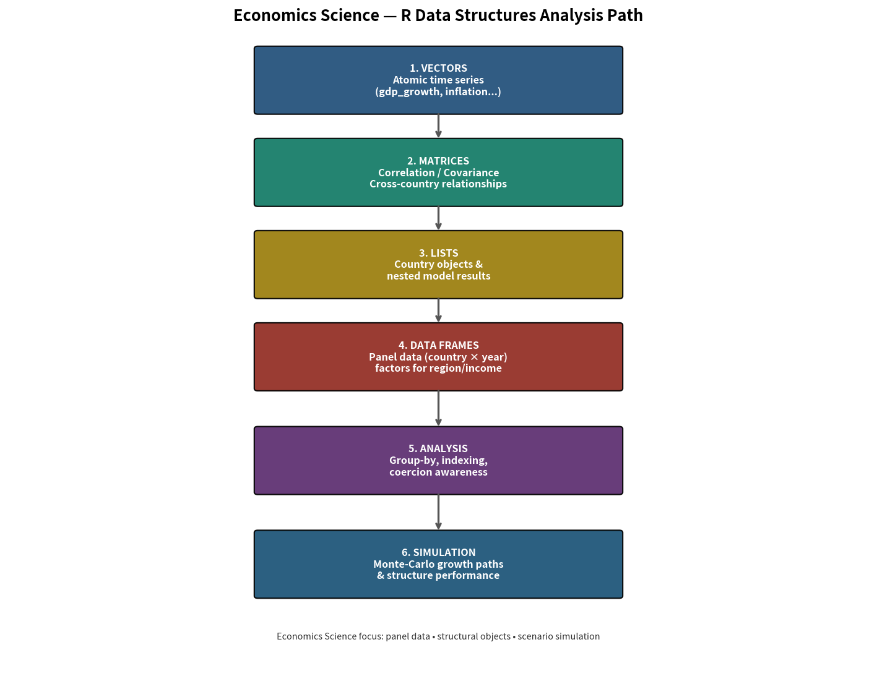
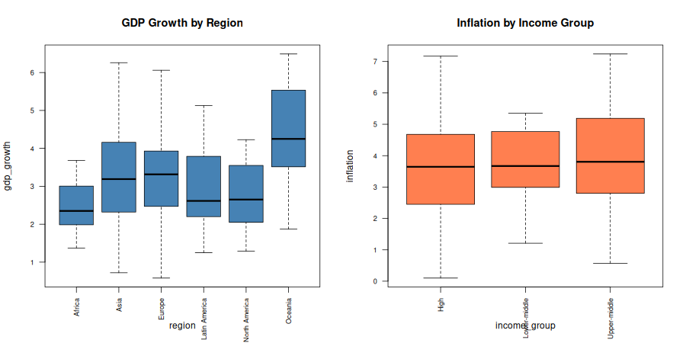
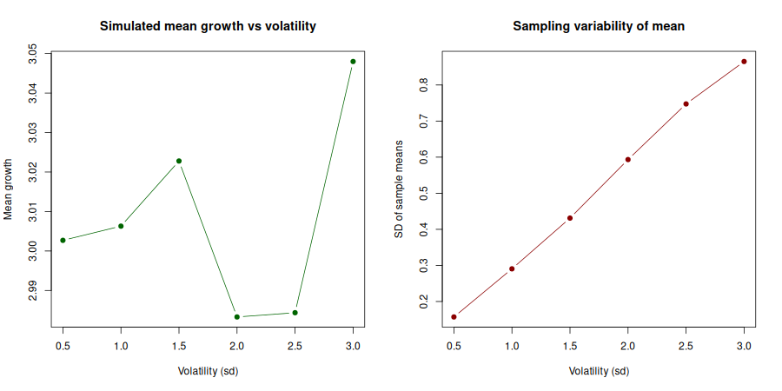

Key Takeaways
• Choose vectors for single series, matrices for linear relationships, lists for heterogeneous country objects, and data frames + factors for panel analysis.
• Coercion and factor levels matter: ordered income groups preserve ranking; character region columns become factors for clean grouping.
• Base-R (tapply / aggregate / split) and dplyr produce identical regional summaries — choose the style that matches audience code literacy.
• Monte-Carlo confirms that the precision of estimated average growth deteriorates linearly with process volatility — useful for study-design decisions.

